Пояснительная записка

Приложение для проведения и создания психологических тестов.

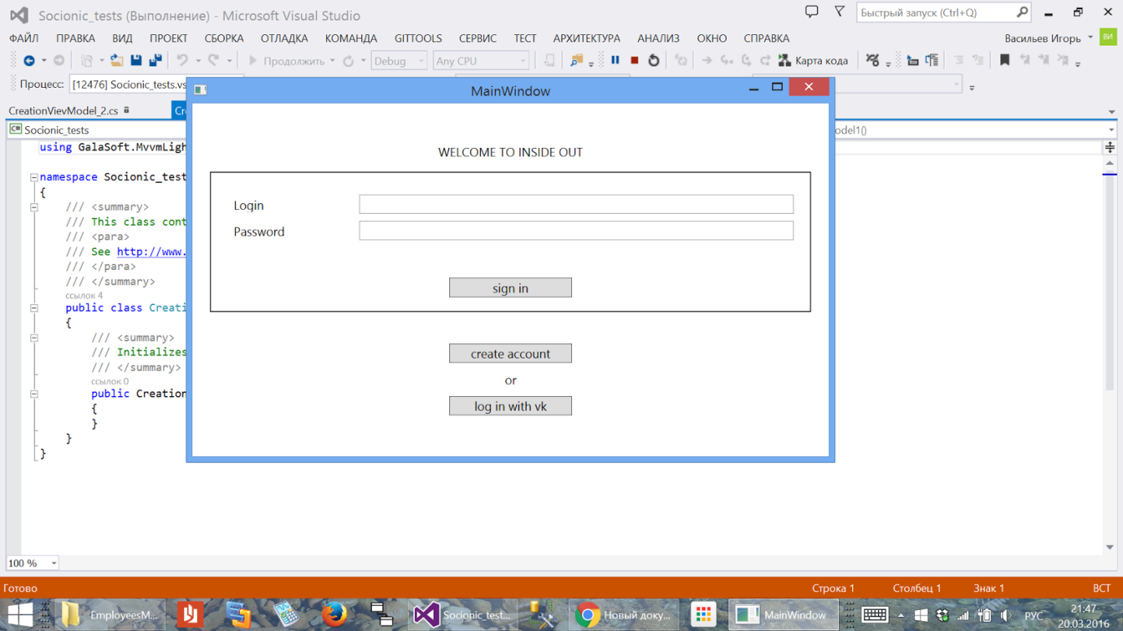

Начальный экран включает в себя возможность зайти через аккаунт, который зафиксирован в  Базе данных. В поля Login и Password  вводятся данные, по кнопке Sign In происходит аутентификация и переход к профайлу пользователя.

Кнопка Create account позволяет перейти к созданию аккаунта.

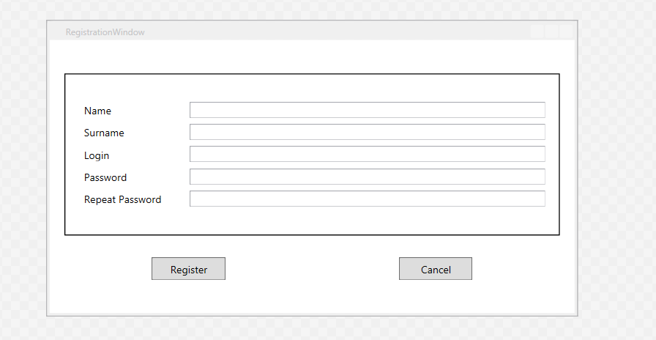

Кнопка Log In позволяет через API vk.com получить token для использования его в дальнейших целях, например, для аутентификации приложения и  публикации результатов теста.

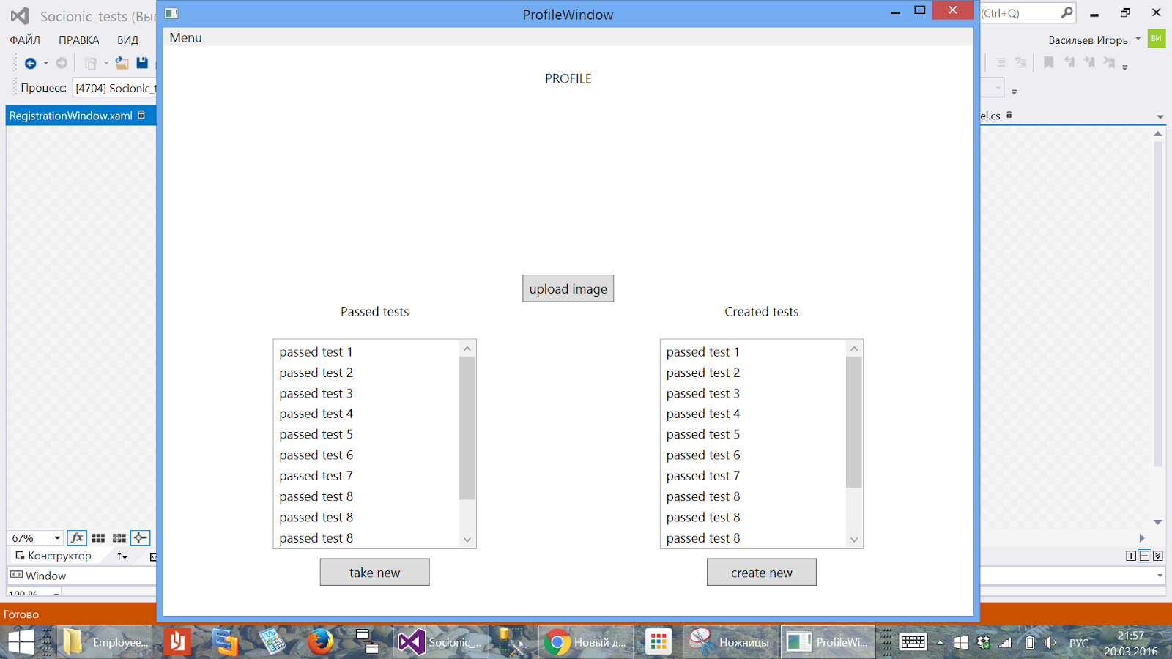

Profile window состоит из 1) Кнопки, позволяющей загрузить фотографию 2) списка завершенных тестов 3) списка созданных тестов 4) кнопка Take new - позволяет пройти тест 5) Кнопка Create new позволяет создать новый тест

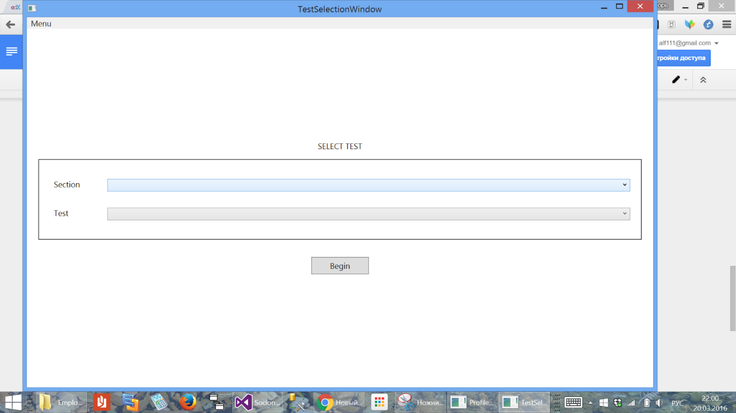

По нажатию кнопки Take new открывается окно выбора тестов, где можно выбрать тему теста и название теста. По кнопке Begin тест начинается.

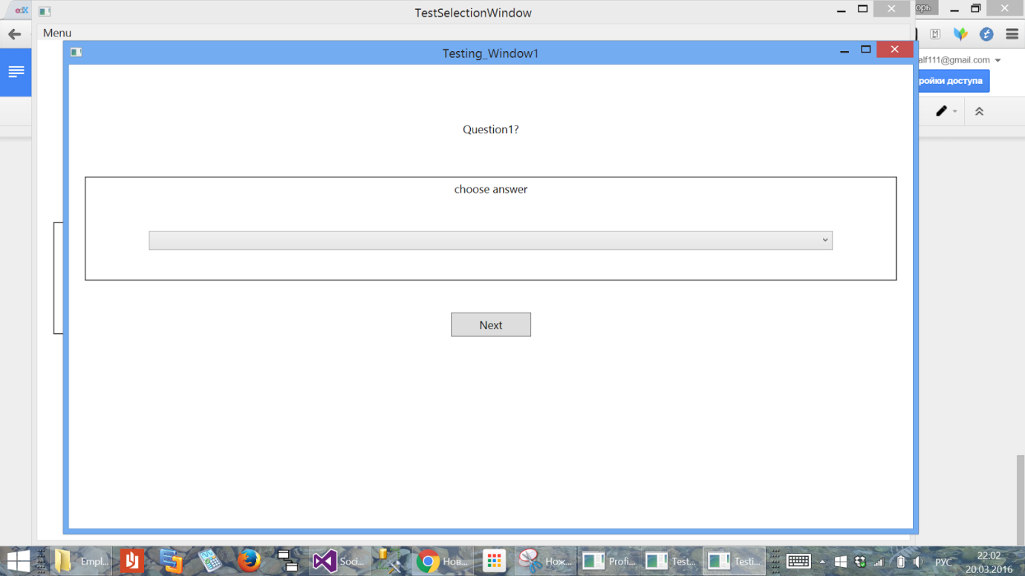

Окно тестирования состоит из 1)Вопроса 2) List box с вариантами ответов 3) Кнопки next, которая подтверждает переход к следующему вопросу, либо же, ведет к окну с реккомендациями.

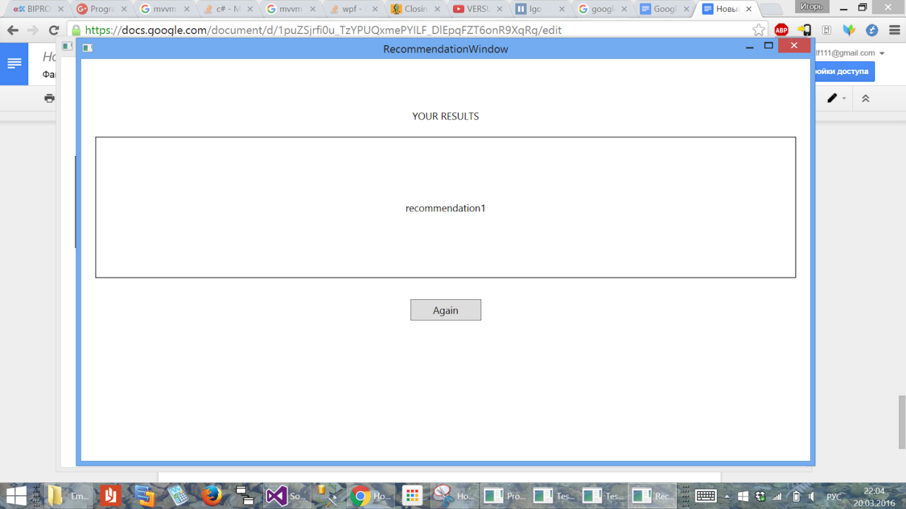

Окно реккомендации состоит из TextBlock с результатом теста и кнопки Again, которая отправляет на страницу Profile.

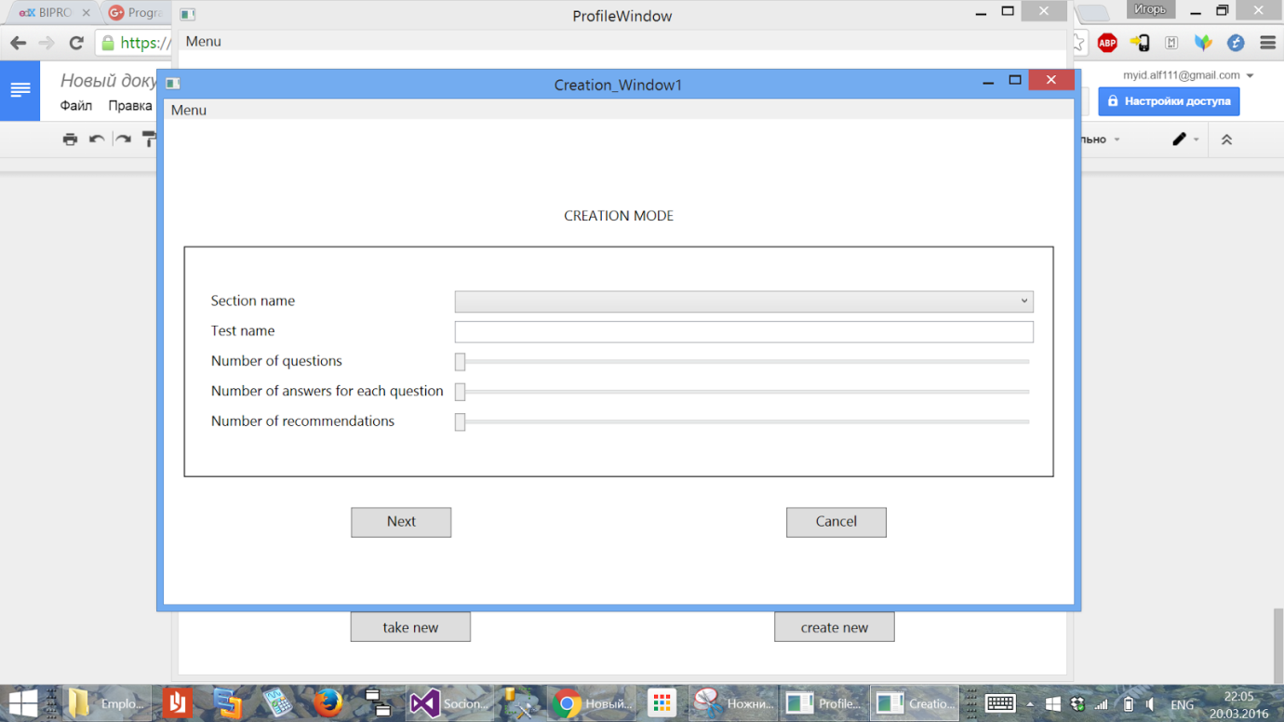Страница создания тестов состоит из трех частей, первая - изображена выше. Здесь можно выбрать тему и название теста, количество вопросов, количество ответов на вопросы, количество возможных рекомендаций. Кнопка Next - переход к следующему окну.

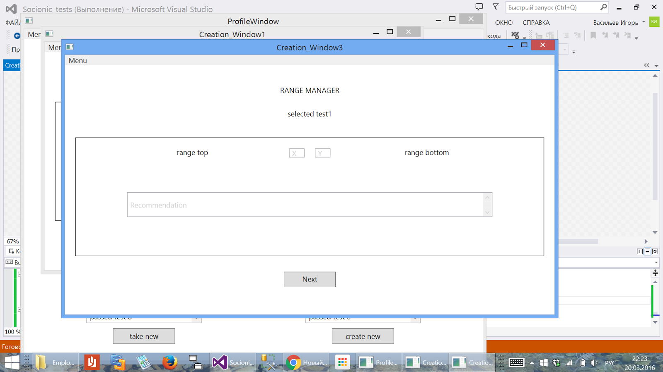

Вторая страница, описывает реккомендации.

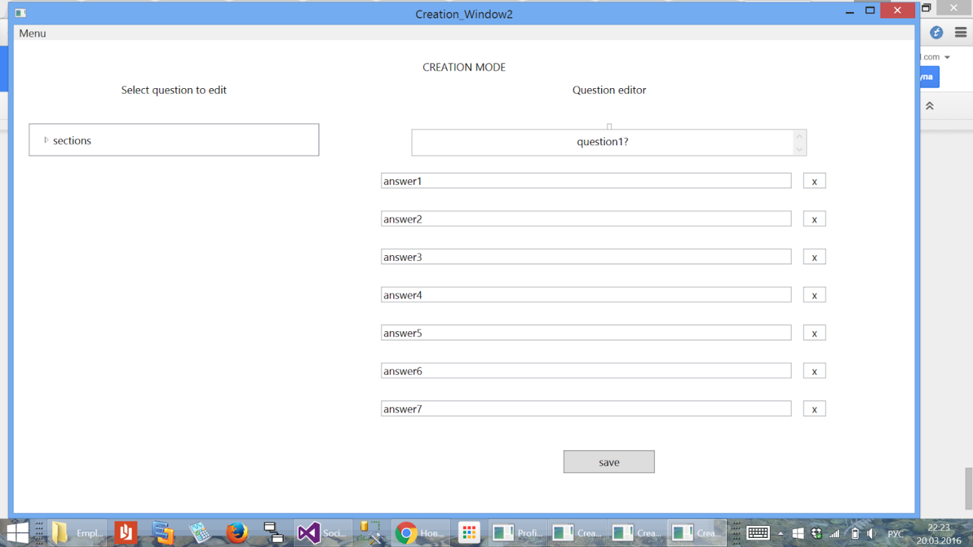Третья страница описывает возможные варианты ответа. По нажатию кнопки Save происходит сохранение результата.

Структура проекта

Проект построен по структуре MVVM

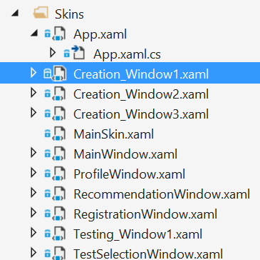

Всего в приложении 9 окон, описанных выше.

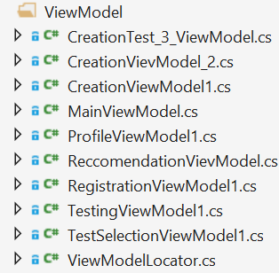

Также,  в соответствии с View есть 9 классов ViewModel и класс ModelLocator

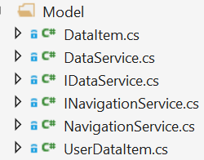

В папке Model хранятся 6 классов, включая 2 интерфейса. INavigationService используется для навигации между окнами.

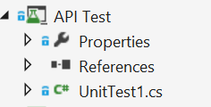

Также, присутствует отдельный проект тестов

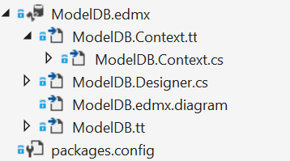

Данные сосредоточены в базе данных на основе SQL сервера

Структура данных:

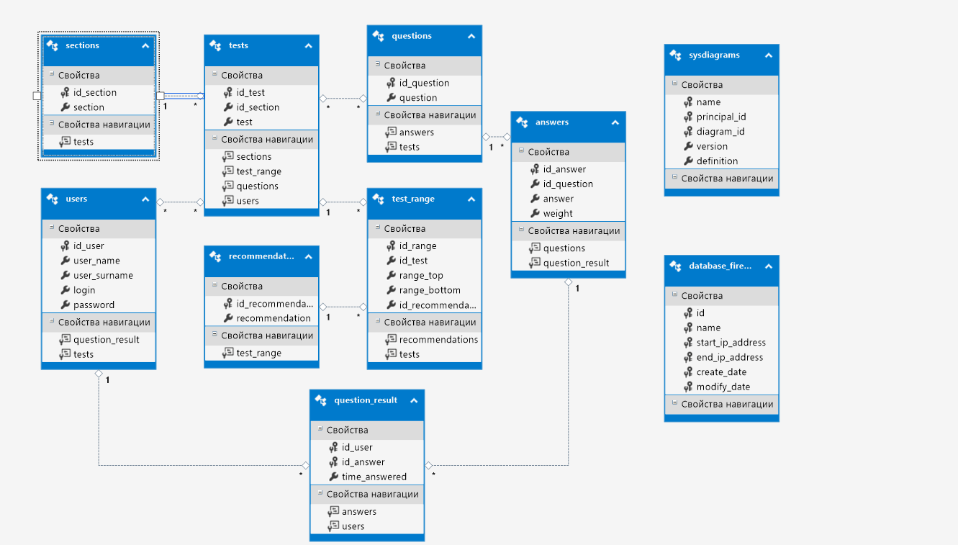

Содержание классов:

|  |
| --- |
| public class ViewModelLocator |
| /*  In App.xaml:  <Application.Resources>  <vm:ViewModelLocatorTemplate xmlns:vm="clr-namespace:Socionic_tests.ViewModel"  x:Key="Locator" />  </Application.Resources>    In the View:  DataContext="{Binding Source={StaticResource Locator}, Path=ViewModelName}"  */  using GalaSoft.MvvmLight;  using GalaSoft.MvvmLight.Ioc;  using Microsoft.Practices.ServiceLocation;  using Socionic_tests.Model;  namespace Socionic_tests.ViewModel  {  /// <summary>  /// This class contains static references to all the view models in the  /// application and provides an entry point for the bindings.  /// <para>  /// See http://www.mvvmlight.net  /// </para>  /// </summary>  public class ViewModelLocator  {    static ViewModelLocator()  {  ServiceLocator.SetLocatorProvider(() => SimpleIoc.Default);  SimpleIoc.Default.Register<MainViewModel>();  SimpleIoc.Default.Register<CreationVievModel_2>();  SimpleIoc.Default.Register<CreationViewModel1>();  SimpleIoc.Default.Register<ProfileViewModel1>();  SimpleIoc.Default.Register<RegistrationViewModel1>();  SimpleIoc.Default.Register<TestingViewModel1>();  SimpleIoc.Default.Register<TestSelectionViewModel1>();  SimpleIoc.Default.Register<ReccomendationVievModel>();  SimpleIoc.Default.Register<CreationTest_3_ViewModel>();  }  /// <summary>  /// Gets the Main property.  /// </summary>  [System.Diagnostics.CodeAnalysis.SuppressMessage("Microsoft.Performance",  "CA1822:MarkMembersAsStatic",  Justification = "This non-static member is needed for data binding purposes.")]  // ServiceLocator.Current.GetInstance<MainViewModel>();  public INavigationService NavigationService  {  get  {  return new NavigationService();  }    }  public CreationTest_3_ViewModel TestCreationPart_3  {  get  {  return ServiceLocator.Current.GetInstance<CreationTest_3_ViewModel>();  }  }  public ReccomendationVievModel Reccomendation  {  get  {  return ServiceLocator.Current.GetInstance<ReccomendationVievModel>();  }  }  public MainViewModel Main  {  get  {  return ServiceLocator.Current.GetInstance<MainViewModel>();  }  }  public CreationViewModel1 TestCreationPartOne  {  get  {  return ServiceLocator.Current.GetInstance<CreationViewModel1>();  }  }  public CreationVievModel_2 TestCreationPartTwo  {  get  {  return ServiceLocator.Current.GetInstance<CreationVievModel_2>();  }  }  public TestSelectionViewModel1 SelectTest  {  get  {  return ServiceLocator.Current.GetInstance<TestSelectionViewModel1>();  }  }  public ProfileViewModel1 ChangeProfile  {  get  {  return ServiceLocator.Current.GetInstance<ProfileViewModel1>();  }  }  public RegistrationViewModel1 RegisterProfile  {  get  {  return ServiceLocator.Current.GetInstance<RegistrationViewModel1>();  }  }  public TestingViewModel1 Testing  {  get  {  return ServiceLocator.Current.GetInstance<TestingViewModel1>();  }  }  /// <summary>  /// Cleans up all the resources.  /// </summary>  public static void Cleanup()  {  }  }  } |

|  |
| --- |
| public class TestSelectionViewModel1 |
| using GalaSoft.MvvmLight;  using GalaSoft.MvvmLight.Command;  namespace Socionic_tests.ViewModel  {  /// <summary>  /// This class contains properties that a View can data bind to.  /// <para>  /// See http://www.galasoft.ch/mvvm  /// </para>  /// </summary>  public class TestSelectionViewModel1 : ViewModelBase  {  /// <summary>  /// Initializes a new instance of the TestSelectionViewModel1 class.  /// </summary>  private ViewModelLocator _lockator;  public TestSelectionViewModel1()  {  _lockator = new ViewModelLocator();  BeginCommand = new RelayCommand(BeginPressed);  }  private void BeginPressed()  {  _lockator.NavigationService.NavigateTo("testing");  }  public RelayCommand BeginCommand { get; set; }  }  } |

|  |
| --- |
| public class TestingViewModel1 |
| using GalaSoft.MvvmLight;  using GalaSoft.MvvmLight.Command;  namespace Socionic_tests.ViewModel  {  /// <summary>  /// This class contains properties that a View can data bind to.  /// <para>  /// See http://www.galasoft.ch/mvvm  /// </para>  /// </summary>  public class TestingViewModel1 : ViewModelBase  {  /// <summary>  /// Initializes a new instance of the TestingViewModel1 class.  /// </summary>  private ViewModelLocator _lockator;  public TestingViewModel1()  {  _lockator = new ViewModelLocator();  GoToReccomendation = new RelayCommand(OpenReccomendationPage);  }  private void OpenReccomendationPage()  {  _lockator.NavigationService.NavigateTo("reccomendation");  }  public RelayCommand GoToReccomendation { get; set; }  }  } |

|  |
| --- |
| RegistrationViewModel1 |
| using GalaSoft.MvvmLight;  using GalaSoft.MvvmLight.Command;  namespace Socionic_tests.ViewModel  {  /// <summary>  /// This class contains properties that a View can data bind to.  /// <para>  /// See http://www.galasoft.ch/mvvm  /// </para>  /// </summary>  public class RegistrationViewModel1 : ViewModelBase  {  /// <summary>  /// Initializes a new instance of the RegistrationViewModel1 class.  /// </summary>  private ViewModelLocator _lockator;  public RegistrationViewModel1()  {  _lockator = new ViewModelLocator();    }    }  } |

|  |
| --- |
| public class ReccomendationVievModel |
| using GalaSoft.MvvmLight;  using GalaSoft.MvvmLight.Command;  namespace Socionic_tests.ViewModel  {  /// <summary>  /// This class contains properties that a View can data bind to.  /// <para>  /// See http://www.galasoft.ch/mvvm  /// </para>  /// </summary>  public class ReccomendationVievModel : ViewModelBase  {  /// <summary>  /// Initializes a new instance of the ReccomendationVievModel class.  /// </summary>  private ViewModelLocator _lockator;  public ReccomendationVievModel()  {  _lockator = new ViewModelLocator();  GoTestAgain = new RelayCommand(TestingAgain);  }  private void TestingAgain()  {  _lockator.NavigationService.NavigateTo("profile");  }  public RelayCommand GoTestAgain { get; set; }  }  } |

|  |
| --- |
| using GalaSoft.MvvmLight;  using GalaSoft.MvvmLight.Command;  namespace Socionic_tests.ViewModel  {  /// <summary>  /// This class contains properties that a View can data bind to.  /// <para>  /// See http://www.galasoft.ch/mvvm  /// </para>  /// </summary>  public class ProfileViewModel1 : ViewModelBase  {  /// <summary>  /// Initializes a new instance of the ProfileViewModel1 class.  /// </summary>  private ViewModelLocator _lockator;  public ProfileViewModel1()  {  _lockator = new ViewModelLocator();  TakeNewTest = new RelayCommand(TakeTest);  CreateTest = new RelayCommand(CreateNewTest);  }  public RelayCommand CreateTest { get; set; }  private void CreateNewTest()  {  _lockator.NavigationService.NavigateTo("creationWin_1");  }  public RelayCommand TakeNewTest { get; set; }    private void TakeTest()  {  _lockator.NavigationService.NavigateTo("TestSelection");  }  }  } |
| using GalaSoft.MvvmLight;  using GalaSoft.MvvmLight.Command;  namespace Socionic_tests.ViewModel  {  /// <summary>  /// This class contains properties that a View can data bind to.  /// <para>  /// See http://www.galasoft.ch/mvvm  /// </para>  /// </summary>  public class ProfileViewModel1 : ViewModelBase  {  /// <summary>  /// Initializes a new instance of the ProfileViewModel1 class.  /// </summary>  private ViewModelLocator _lockator;  public ProfileViewModel1()  {  _lockator = new ViewModelLocator();  TakeNewTest = new RelayCommand(TakeTest);  CreateTest = new RelayCommand(CreateNewTest);  }  public RelayCommand CreateTest { get; set; }  private void CreateNewTest()  {  _lockator.NavigationService.NavigateTo("creationWin_1");  }  public RelayCommand TakeNewTest { get; set; }    private void TakeTest()  {  _lockator.NavigationService.NavigateTo("TestSelection");  }  }  } |

|  |
| --- |
| public class MainViewModel |
| using GalaSoft.MvvmLight;  using GalaSoft.MvvmLight.Command;  using Socionic_tests.Model;  using System.Windows.Input;  namespace Socionic_tests.ViewModel  {  /// <summary>  /// This class contains properties that the main View can data bind to.  /// <para>  /// See http://www.mvvmlight.net  /// </para>  /// </summary>  public class MainViewModel : ViewModelBase  {  public UserDataItem User { get; set; }  public RelayCommand LogInCommand { get; private set; }  private ViewModelLocator _lockator;  public MainViewModel()  {  _lockator = new ViewModelLocator();  SignUp = new RelayCommand(Sign_Up);  LogVK = new RelayCommand(Log_VK);  LogInCommand = new RelayCommand(OnLogInCommand);  }  private void Log_VK()  {    }  private void Sign_Up()  {  _lockator.NavigationService.NavigateTo("reg");    App.Current.MainWindow.Close();  }  public RelayCommand SignUp { get; set; }  public RelayCommand LogVK { get; set; }  private void OnLogInCommand()  {  // string testUsername = Username;  // string testPassword = Password;  _lockator.NavigationService.NavigateTo("profile");  App.Current.MainWindow.Close();  }  #region Properties  public string Username  {  get { return User.Login; }  set { User.Login = value; }  }  public string Password  {  get { return User.Password; }  set { User.Password = value; }  }  #endregion    }  } |

|  |
| --- |
| public class CreationViewModel1 |
| using GalaSoft.MvvmLight;  using GalaSoft.MvvmLight.Command;  namespace Socionic_tests.ViewModel  {  /// <summary>  /// This class contains properties that a View can data bind to.  /// <para>  /// See http://www.galasoft.ch/mvvm  /// </para>  /// </summary>  public class CreationViewModel1 : ViewModelBase  {  /// <summary>  /// Initializes a new instance of the CreationViewModel1 class.  /// </summary>  private ViewModelLocator _lockator;  public CreationViewModel1()  {  _lockator = new ViewModelLocator();  ToTheMiddleCreationPage = new RelayCommand(MoveToTheMiddle);  }  private void MoveToTheMiddle()  {  _lockator.NavigationService.NavigateTo("creationWin_3");  }  public RelayCommand ToTheMiddleCreationPage { get; set; }  }  } |

|  |
| --- |
| public class CreationVievModel_2 : ViewModelBase |
| using GalaSoft.MvvmLight;  namespace Socionic_tests.ViewModel  {  /// <summary>  /// This class contains properties that a View can data bind to.  /// <para>  /// See http://www.galasoft.ch/mvvm  /// </para>  /// </summary>  public class CreationVievModel_2 : ViewModelBase  {  /// <summary>  /// Initializes a new instance of the CreationVievModel_2 class.  /// </summary>  public CreationVievModel_2()  {  }  }  } |

|  |
| --- |
| public class CreationTest_3_ViewModel |
| using GalaSoft.MvvmLight;  using GalaSoft.MvvmLight.Command;  namespace Socionic_tests.ViewModel  {  /// <summary>  /// This class contains properties that a View can data bind to.  /// <para>  /// See http://www.galasoft.ch/mvvm  /// </para>  /// </summary>  public class CreationTest_3_ViewModel : ViewModelBase  {  /// <summary>  /// Initializes a new instance of the CreationTest_3_ViewModel class.  /// </summary>  private ViewModelLocator _lockator;  public CreationTest_3_ViewModel()  {  _lockator = new ViewModelLocator();  ToLastCreationPage = new RelayCommand(ToTheLastPage);  }  private void ToTheLastPage()  {  _lockator.NavigationService.NavigateTo("creationWin_2");  }  public RelayCommand ToLastCreationPage { get; set; }  }  } |

|  |
| --- |
| Repository |
| using System;  using System.Collections.Generic;  using System.Linq;  using System.Text;  using System.Threading.Tasks;  using Socionic_tests.Model;  namespace Socionic_tests.Repository  {  class Repository  {  private int _countTestPoints;  public int CountTestPoints  {  get { return _countTestPoints; }  set { _countTestPoints = value; }  }  ICollection<UserDataItem> _users = new List<UserDataItem>();    }  } |

|  |
| --- |
|  |
| using System;  using System.Collections.Generic;  using System.Linq;  using System.Text;  using System.Threading.Tasks;  namespace Socionic_tests.Model  {  public class UserDataItem  {  public int ID { get; set; }  public string User_Name { get; set; }  public string User_Surname { get; set; }  public string Login { get; set; }  public string Password { get; set; }  }  } |

|  |
| --- |
|  |
| using System;  using System.Collections.Generic;  using System.Linq;  using System.Text;  using System.Threading.Tasks;  using System.Windows;  using Socionic_tests.Skins;  namespace Socionic_tests.Model  {  public class NavigationService: INavigationService  {  Dictionary<string, Window> _windows = new Dictionary<string, Window>();  public void NavigateTo(string window)  {  Window winObj;  if(_windows.TryGetValue(window, out winObj))  {  winObj.Show();  }  }  public NavigationService()  {    _windows["main"] = new MainWindow();  _windows["profile"] = new ProfileWindow();  _windows["reg"] = new RegistrationWindow();  _windows["testing"] = new Testing_Window1();  _windows["TestSelection"] = new TestSelectionWindow();  _windows["reccomendation"] = new RecommendationWindow();  _windows["creationWin_1"] = new Creation_Window1();  _windows["creationWin_2"] = new Creation_Window2();  _windows["creationWin_3"] = new Creation_Window3();  }  }  } |

|  |
| --- |
|  |
| using System;  using System.Collections.Generic;  using System.Linq;  using System.Text;  using System.Threading.Tasks;  namespace Socionic_tests.Model  {  public interface INavigationService  {  void NavigateTo(string window);  }  } |

|  |
| --- |
| Class="Socionic_tests.Skins.TestSelectionWindow |
| <Window x: Class="Socionic_tests.Skins.TestSelectionWindow "  xmlns="http://schemas.microsoft.com/winfx/2006/xaml/presentation"  xmlns:x="http://schemas.microsoft.com/winfx/2006/xaml"  xmlns:d="http://schemas.microsoft.com/expression/blend/2008"  xmlns:local="clr-namespace:Socionic_tests.Skins"  xmlns:mc="http://schemas.openxmlformats.org/markup-compatibility/2006"  Title="TestSelectionWindow"  Width="680"  Height="440"  MinWidth="560"  MinHeight="340"  DataContext="{Binding SelectTest,  Source={StaticResource Locator}}">  <Window.Resources>  <Style x:Key="MyTextStyle">  <Setter Property="Control.FontFamily" Value="Lucida" />  <Setter Property="Control.FontSize" Value="14" />  <Setter Property="Control.FontWeight" Value="Regular" />  <Setter Property="Control.Foreground" Value="Black" />  <Setter Property="Control.VerticalAlignment" Value="Center" />  <Setter Property="Control.HorizontalAlignment" Value="Center" />  </Style>  </Window.Resources>  <DockPanel>  <Menu DockPanel.Dock="Top">  <MenuItem Height="20"  FontSize="14"  Header="Menu">  <MenuItem Height="20"  FontSize="14"  Header="Profile" />  <MenuItem Height="20"  FontSize="14"  Header="New test">  <MenuItem Height="20"  FontSize="14"  Header="Take" />  <MenuItem Height="20"  FontSize="14"  Header="Create" />  </MenuItem>  <MenuItem Height="20"  FontSize="14"  Header="Log out" />  <MenuItem Height="20"  Cursor="Help"  FontSize="14"  Header="About">  <MenuItem Height="20"  FontSize="14"  Header="Read" />  </MenuItem>  </MenuItem>  </Menu>  <Grid Margin="20 20" VerticalAlignment="Center">  <Grid.RowDefinitions>  <RowDefinition Height="30" />  <RowDefinition Height="140" />  <RowDefinition Height="30" />  <RowDefinition Height="30" />  </Grid.RowDefinitions>  <Grid.ColumnDefinitions>  <ColumnDefinition />  <ColumnDefinition />  </Grid.ColumnDefinitions>  <TextBlock Grid.Row="0"  Grid.Column="0"  Grid.ColumnSpan="2"  VerticalAlignment="Top"  Style="{StaticResource MyTextStyle}"  Text="SELECT TEST" />  <StackPanel Grid.Row="1"  Grid.Column="0"  Grid.ColumnSpan="2"  Margin="20 20"  VerticalAlignment="Center">  <Grid>  <Grid.RowDefinitions>  <RowDefinition Height="30" />  <RowDefinition Height="30" />  <RowDefinition Height="20" />  <RowDefinition Height="30" />  <RowDefinition Height="30" />  <RowDefinition />  </Grid.RowDefinitions>  <Grid.ColumnDefinitions>  <ColumnDefinition Width="100" />  <ColumnDefinition />  </Grid.ColumnDefinitions>  <TextBlock Grid.Row="1"  Margin="7 0"  HorizontalAlignment="Left"  Style="{StaticResource MyTextStyle}"  Text="Section" />  <ComboBox Grid.Row="1"  Grid.Column="1"  Height="22"  VerticalAlignment="Center"  FontSize="14" />  <TextBlock Grid.Row="3"  Margin="7 0"  HorizontalAlignment="Left"  Style="{StaticResource MyTextStyle}"  Text="Test" />  <ComboBox Grid.Row="3"  Grid.Column="1"  Height="22"  VerticalAlignment="Center"  FontSize="14" />  </Grid>  </StackPanel>  <Border Grid.Row="1"  Grid.Column="0"  Grid.ColumnSpan="2"  BorderBrush="Black"  BorderThickness="1" />  <Button Grid.Row="3"  Grid.Column="0"  Grid.ColumnSpan="2"  MinWidth="100"  MinHeight="30"  MaxWidth="100"  MaxHeight="30"  VerticalAlignment="Center"  Command="{Binding BeginCommand}"  Content="Begin"  Cursor="Hand"  FontSize="14" />  </Grid>  </DockPanel>  </Window> |

|  |
| --- |
|  |
| <Window x:Class="Socionic_tests.Skins.Testing_Window1"  xmlns="http://schemas.microsoft.com/winfx/2006/xaml/presentation"  xmlns:x="http://schemas.microsoft.com/winfx/2006/xaml"  xmlns:d="http://schemas.microsoft.com/expression/blend/2008"  xmlns:local="clr-namespace:Socionic_tests.Skins"  xmlns:mc="http://schemas.openxmlformats.org/markup-compatibility/2006"  Title="Testing_Window1"  Width="720"  Height="480"  MinWidth="560"  MinHeight="420"  DataContext="{Binding Testing,  Source={StaticResource Locator}}"  mc:Ignorable="d">  <Grid Margin="20 20">  <Grid.ColumnDefinitions>  <ColumnDefinition />  <ColumnDefinition />  </Grid.ColumnDefinitions>  <Grid.RowDefinitions>  <RowDefinition Height="120" />  <RowDefinition Height="30" />  <RowDefinition Height="100" />  <RowDefinition Height="40" />  <RowDefinition Height="30" />  <RowDefinition Height="30" />  </Grid.RowDefinitions>  <TextBlock Grid.Column="0"  Grid.ColumnSpan="2"  HorizontalAlignment="Center"  VerticalAlignment="Center"  FontSize="14"  Text="Question1?"  TextAlignment="Center" />  <TextBlock Grid.Row="1"  Grid.Column="0"  Grid.ColumnSpan="2"  HorizontalAlignment="Center"  VerticalAlignment="Center"  FontSize="14">  choose answer  </TextBlock>  <Border Grid.Row="1"  Grid.RowSpan="2"  Grid.Column="0"  Grid.ColumnSpan="2"  BorderBrush="Black"  BorderThickness="1" />  <ComboBox Grid.Row="2"  Grid.Column="0"  Grid.ColumnSpan="2"  Margin="80 0"  VerticalAlignment="Center"  FontSize="14">  <ComboBoxItem Content="answer1" />  <ComboBoxItem Content="answer2" />  <ComboBoxItem Content="answer3" />  <ComboBoxItem Content="answer4" />  </ComboBox>  <Button Grid.Row="4"  Grid.Column="0"  Grid.ColumnSpan="2"  MinWidth="100"  MinHeight="30"  MaxWidth="100"  MaxHeight="30"  VerticalAlignment="Center"  Command="{Binding GoToReccomendation}"  Content="Next"  Cursor="Hand"  FontSize="14" />  </Grid>  </Window> |

|  |
| --- |
|  |
| <Window x:Class="Socionic_tests.Skins.RegistrationWindow"  xmlns="http://schemas.microsoft.com/winfx/2006/xaml/presentation"  xmlns:x="http://schemas.microsoft.com/winfx/2006/xaml"  xmlns:d="http://schemas.microsoft.com/expression/blend/2008"  xmlns:local="clr-namespace:Socionic_tests.Skins"  xmlns:mc="http://schemas.openxmlformats.org/markup-compatibility/2006"  Title="RegistrationWindow"  Width="720"  Height="400"  MinWidth="420"  MinHeight="380"  DataContext="{Binding RegisterProfile,  Source={StaticResource Locator}}"  mc:Ignorable="d">  <Grid Margin="20 20" VerticalAlignment="Center">  <Grid.RowDefinitions>  <RowDefinition Height="220" />  <RowDefinition Height="30" />  <RowDefinition Height="30" />  </Grid.RowDefinitions>  <Grid.ColumnDefinitions>  <ColumnDefinition />  <ColumnDefinition />  </Grid.ColumnDefinitions>  <StackPanel Grid.Row="0"  Grid.Column="0"  Grid.ColumnSpan="2"  Margin="20 20"  VerticalAlignment="Center">  <Grid>  <Grid.RowDefinitions>  <RowDefinition Height="20" />  <RowDefinition Height="30" />  <RowDefinition Height="30" />  <RowDefinition Height="30" />  <RowDefinition Height="30" />  <RowDefinition Height="30" />  <RowDefinition Height="20" />  <RowDefinition />  </Grid.RowDefinitions>  <Grid.ColumnDefinitions>  <ColumnDefinition Width="150" />  <ColumnDefinition />  </Grid.ColumnDefinitions>  <TextBlock Grid.Row="1"  Height="18"  Margin="7 0"  VerticalAlignment="Center"  FontSize="14"  Text="Name" />  <TextBox Grid.Row="1"  Grid.Column="1"  Height="22"  Margin="0,4"  VerticalAlignment="Center"  FontSize="14" />  <TextBlock Grid.Row="2"  Height="18"  Margin="7 0"  VerticalAlignment="Center"  FontSize="14">  Surname  </TextBlock>  <TextBox Grid.Row="2"  Grid.Column="1"  Height="22"  Margin="0,4"  VerticalAlignment="Center"  FontSize="14" />  <TextBlock Grid.Row="3"  Height="18"  Margin="7 0"  VerticalAlignment="Center"  FontSize="14"  Text="Login" />  <TextBox Grid.Row="3"  Grid.Column="1"  Height="22"  Margin="0,4"  VerticalAlignment="Center"  FontSize="14" />  <TextBlock Grid.Row="4"  Height="18"  Margin="7 0"  VerticalAlignment="Center"  FontSize="14"  Text="Password" />  <PasswordBox Grid.Row="4"  Grid.Column="1"  Height="22"  Margin="0,4"  VerticalAlignment="Center"  FontSize="14" />  <TextBlock Grid.Row="5"  Height="18"  Margin="7 0"  VerticalAlignment="Center"  FontSize="14"  Text="Repeat Password" />  <PasswordBox Grid.Row="5"  Grid.Column="1"  Height="22"  Margin="0,4"  VerticalAlignment="Center"  FontSize="14" />  </Grid>  </StackPanel>  <Border Grid.Row="0"  Grid.Column="0"  Grid.ColumnSpan="2"  BorderBrush="Black"  BorderThickness="1" />  <Button Grid.Row="2"  MaxHeight ="30"  MaxWidth ="100"  MinHeight="30"  MinWidth="100"  Cursor="Hand"  VerticalAlignment="Center"  Content="Register"  FontSize="14" />  <Button Grid.Row="2"  Grid.Column="1"  MaxHeight ="30"  MaxWidth ="100"  MinHeight="30"  MinWidth="100"  Cursor="Hand"  VerticalAlignment="Center"  Content="Cancel"  FontSize="14" />  </Grid>  </Window> |

|  |
| --- |
|  |
| <Window x:Class="Socionic_tests.Skins.RecommendationWindow"  xmlns="http://schemas.microsoft.com/winfx/2006/xaml/presentation"  xmlns:x="http://schemas.microsoft.com/winfx/2006/xaml"  xmlns:d="http://schemas.microsoft.com/expression/blend/2008"  xmlns:local="clr-namespace:Socionic_tests.Skins"  xmlns:mc="http://schemas.openxmlformats.org/markup-compatibility/2006"  Title="RecommendationWindow"  Width="720"  Height="440"  MinWidth="560"  MinHeight="430"  DataContext="{Binding Reccomendation,  Source={StaticResource Locator}}"  mc:Ignorable="d">  <Grid Margin="20 20">  <Grid.RowDefinitions>  <RowDefinition Height="30" />  <RowDefinition Height="30" />  <RowDefinition Height="30" />  <RowDefinition Height="200" />  <RowDefinition Height="30" />  <RowDefinition Height="30" />  <RowDefinition Height="30" />  </Grid.RowDefinitions>  <Grid.ColumnDefinitions>  <ColumnDefinition />  <ColumnDefinition />  </Grid.ColumnDefinitions>  <TextBlock Grid.Row="1"  Grid.RowSpan="2"  Grid.Column="0"  Grid.ColumnSpan="2"  HorizontalAlignment="Center"  VerticalAlignment="Center"  FontSize="14"  Text="YOUR RESULTS" />  <TextBlock Grid.Row="3"  Grid.Column="0"  Grid.ColumnSpan="2"  HorizontalAlignment="Center"  VerticalAlignment="Center"  FontSize="14"  Text="recommendation1"  TextAlignment="Center" />  <Border Grid.Row="3"  Grid.Column="0"  Grid.ColumnSpan="2"  BorderBrush="Black"  BorderThickness="1" />  <Button Grid.Row="5"  Grid.Column="0"  Grid.ColumnSpan="2"  MinWidth="100"  MinHeight="30"  MaxWidth="100"  MaxHeight="30"  VerticalAlignment="Center"  Command="{Binding GoTestAgain}"  Content="Again"  Cursor="Hand"  FontSize="14" />  </Grid>  </Window> |

|  |
| --- |
|  |
| <Window x:Class="Socionic_tests.Skins.ProfileWindow"  xmlns="http://schemas.microsoft.com/winfx/2006/xaml/presentation"  xmlns:x="http://schemas.microsoft.com/winfx/2006/xaml"  xmlns:d="http://schemas.microsoft.com/expression/blend/2008"  xmlns:local="clr-namespace:Socionic_tests.Skins"  xmlns:mc="http://schemas.openxmlformats.org/markup-compatibility/2006"  Title="ProfileWindow"  Width="900"  Height="680"  MinWidth="700"  MinHeight="380"  DataContext="{Binding ChangeProfile,  Source={StaticResource Locator}}">  <DockPanel>  <Menu DockPanel.Dock="Top">  <MenuItem Height="20"  FontSize="14"  Header="Menu">  <MenuItem Height="20"  FontSize="14"  Header="Profile" />  <MenuItem Height="20"  FontSize="14"  Header="New test">  <MenuItem Height="20"  FontSize="14"  Header="Take" />  <MenuItem Height="20"  FontSize="14"  Header="Create" />  </MenuItem>  <MenuItem Height="20"  FontSize="14"  Header="Log out" />  <MenuItem Height="20"  Cursor="Help"  FontSize="14"  Header="About">  <MenuItem Height="20"  FontSize="14"  Header="read" />  </MenuItem>  </MenuItem>  </Menu>  <Grid Margin="20 20">  <Grid.RowDefinitions>  <RowDefinition Height="30" />  <RowDefinition Height="200" />  <RowDefinition Height="30" />  <RowDefinition Height="30" />  <RowDefinition Height="250" />  <RowDefinition Height="30" />  </Grid.RowDefinitions>  <Grid.ColumnDefinitions>  <ColumnDefinition />  <ColumnDefinition />  </Grid.ColumnDefinitions>  <TextBlock Grid.Row="0"  Grid.Column="0"  Grid.ColumnSpan="2"  HorizontalAlignment="Center"  VerticalAlignment="Center"  FontSize="14">  PROFILE  </TextBlock>  <Image x:Name="pic1"  Grid.Row="1"  Grid.Column="0"  Grid.ColumnSpan="2"  Margin="300 20 300 20"  Source="pic1.jpg" />  <Button Grid.Row="2"  Grid.Column="0"  Grid.ColumnSpan="2"  MinWidth="100"  MinHeight="30"  MaxWidth="100"  MaxHeight="30"  Content="upload image"  Cursor="Hand"  FontSize="14" />  <TextBlock Grid.Row="3"  Grid.Column="0"  HorizontalAlignment="Center"  VerticalAlignment="Top"  FontSize="14"  Text="Passed tests" />  <TextBlock Grid.Row="3"  Grid.Column="1"  HorizontalAlignment="Center"  VerticalAlignment="Top"  FontSize="14"  Text="Created tests" />  <ListBox Grid.Row="4"  Grid.Column="0"  Margin="100 10 100 10"  FontSize="14">  <ListBoxItem>passed test 1</ListBoxItem>  <ListBoxItem>passed test 2</ListBoxItem>  <ListBoxItem>passed test 3</ListBoxItem>  <ListBoxItem>passed test 4</ListBoxItem>  <ListBoxItem>passed test 5</ListBoxItem>  <ListBoxItem>passed test 6</ListBoxItem>  <ListBoxItem>passed test 7</ListBoxItem>  <ListBoxItem>passed test 8</ListBoxItem>  <ListBoxItem>passed test 8</ListBoxItem>  <ListBoxItem>passed test 8</ListBoxItem>  <ListBoxItem>passed test 8</ListBoxItem>  </ListBox>  <ListBox Grid.Row="4"  Grid.Column="1"  Margin="100 10 100 10"  FontSize="14">  <ListBoxItem>passed test 1</ListBoxItem>  <ListBoxItem>passed test 2</ListBoxItem>  <ListBoxItem>passed test 3</ListBoxItem>  <ListBoxItem>passed test 4</ListBoxItem>  <ListBoxItem>passed test 5</ListBoxItem>  <ListBoxItem>passed test 6</ListBoxItem>  <ListBoxItem>passed test 7</ListBoxItem>  <ListBoxItem>passed test 8</ListBoxItem>  <ListBoxItem>passed test 8</ListBoxItem>  <ListBoxItem>passed test 8</ListBoxItem>  <ListBoxItem>passed test 8</ListBoxItem>  <ListBoxItem>passed test 8</ListBoxItem>  </ListBox>  <Button Grid.Row="5"  MaxWidth="120"  Command="{Binding TakeNewTest}"  FontSize="14">  take new  </Button>  <Button Grid.Row="5"  Grid.Column="1"  MaxWidth="120"  Command="{Binding CreateTest}"  FontSize="14">  create new  </Button>  </Grid>  </DockPanel>  </Window> |

|  |
| --- |
|  |
| <Window x:Class="Socionic_tests.Skins.MainWindow"  xmlns="http://schemas.microsoft.com/winfx/2006/xaml/presentation"  xmlns:x="http://schemas.microsoft.com/winfx/2006/xaml"  xmlns:d="http://schemas.microsoft.com/expression/blend/2008"  xmlns:local="clr-namespace:Socionic_tests.Skins"  xmlns:mc="http://schemas.openxmlformats.org/markup-compatibility/2006"  Title="MainWindow"  Width="740"  Height="440"  MinWidth="410"  MinHeight="320"  DataContext="{Binding Main,  Source={StaticResource Locator}}"  mc:Ignorable="d">  <Grid Margin="20 20">  <Grid.RowDefinitions>  <RowDefinition Height="10" />  <RowDefinition Height="50" />  <RowDefinition Height="100" />  <RowDefinition Height="30" />  <RowDefinition Height="30" />  <RowDefinition Height="30" />  <RowDefinition Height="30" />  <RowDefinition Height="30" />  <RowDefinition Height="30" />  <RowDefinition />  </Grid.RowDefinitions>  <Grid.ColumnDefinitions>  <ColumnDefinition />  </Grid.ColumnDefinitions>  <TextBlock Grid.Row="1"  Grid.Column="0"  Grid.ColumnSpan="2"  HorizontalAlignment="Center"  VerticalAlignment="Center"  FontSize="14">  WELCOME TO INSIDE OUT  </TextBlock>  <Border Grid.Row="1"  Grid.RowSpan="4"  Grid.Column="0"  Margin="0,48,0.333,2"  BorderBrush="Black"  BorderThickness="1" />  <StackPanel Grid.Row="2"  Grid.Column="0"  Grid.ColumnSpan="2"  Margin="20 20"  VerticalAlignment="Center">  <Grid>  <Grid.RowDefinitions>  <RowDefinition Height="30" />  <RowDefinition Height="30" />  <RowDefinition />  </Grid.RowDefinitions>  <Grid.ColumnDefinitions>  <ColumnDefinition Width="150" />  <ColumnDefinition />  </Grid.ColumnDefinitions>  <TextBox Grid.Column="1"  Height="22"  VerticalAlignment="Center"  FontSize="14"  Text="{Binding Username}" />  <TextBlock Grid.Row="0"  Height="18"  Margin="7 0"  VerticalAlignment="Center"  FontSize="14">  Login  </TextBlock>  <TextBlock Grid.Row="1"  Height="18"  Margin="7 0"  VerticalAlignment="Center"  FontSize="14">  Password  </TextBlock>  <TextBox Grid.Row="1"  Grid.Column="1"  Height="22"  VerticalAlignment="Center"  FontSize="14"  Text="{Binding Password}" />  </Grid>  </StackPanel>  <Button Name="signIn"  Grid.Row="3"  Grid.RowSpan="2"  Grid.Column="0"  Grid.ColumnSpan="2"  MinWidth="120"  MaxWidth="140"  VerticalAlignment="Center"  Command="{Binding LogInCommand}"  FontSize="14">  sign in  </Button>  <Button Name="CreateAccount"  Grid.Row="6"  Grid.Column="0"  Grid.ColumnSpan="2"  MinWidth="120"  MaxWidth="140"  VerticalAlignment="Center"  Command="{Binding SignUp,  Mode=OneWay}"  FontSize="14">  create account  </Button>  <TextBlock Grid.Row="7"  Grid.Column="0"  Grid.ColumnSpan="2"  HorizontalAlignment="Center"  VerticalAlignment="Center"  FontSize="14">  or  </TextBlock>  <Button Grid.Row="8"  Grid.Column="0"  Grid.ColumnSpan="2"  MinWidth="120"  MaxWidth="140"  VerticalAlignment="Center"  Command="{Binding LogVK}"  FontSize="14">  log in with vk  </Button>  </Grid>  </Window> |

|  |
| --- |
|  |
| <Window x:Class="Socionic_tests.Skins.Creation_Window3"  xmlns="http://schemas.microsoft.com/winfx/2006/xaml/presentation"  xmlns:x="http://schemas.microsoft.com/winfx/2006/xaml"  xmlns:d="http://schemas.microsoft.com/expression/blend/2008"  xmlns:local="clr-namespace:Socionic_tests.Skins"  xmlns:mc="http://schemas.openxmlformats.org/markup-compatibility/2006"  Title="Creation_Window3"  Height="540"  MinWidth="500"  MinHeight="515"  DataContext="{Binding TestCreationPart_3,  Source={StaticResource Locator}}"  mc:Ignorable="d">  <Window.Resources>  <Style x:Key="MyTextStyle">  <Setter Property="Control.FontFamily" Value="Lucida" />  <Setter Property="Control.FontSize" Value="14" />  <Setter Property="Control.FontWeight" Value="Regular" />  <Setter Property="Control.Foreground" Value="Black" />  <Setter Property="Control.VerticalAlignment" Value="Center" />  <Setter Property="Control.HorizontalAlignment" Value="Center" />  </Style>  <Style x:Key="MyButtonStyle">  <Setter Property="Control.FontFamily" Value="Lucida" />  <Setter Property="Control.FontSize" Value="14" />  <Setter Property="Control.FontWeight" Value="Regular" />  <Setter Property="Control.Foreground" Value="Black" />  <Setter Property="Control.VerticalAlignment" Value="Center" />  <Setter Property="Control.MaxHeight" Value="30" />  <Setter Property="Control.MaxWidth" Value="100" />  <Setter Property="Control.MinHeight" Value="30" />  <Setter Property="Control.MinWidth" Value="100" />  </Style>  </Window.Resources>  <DockPanel>  <Menu DockPanel.Dock="Top">  <MenuItem Height="20"  FontSize="14"  Header="Menu">  <MenuItem Height="20"  FontSize="14"  Header="Profile" />  <MenuItem Height="20"  FontSize="14"  Header="New test">  <MenuItem Height="20"  FontSize="14"  Header="Take" />  <MenuItem Height="20"  FontSize="14"  Header="Create" />  </MenuItem>  <MenuItem Height="20"  FontSize="14"  Header="Log out" />  <MenuItem Height="20"  Cursor="Help"  FontSize="14"  Header="About">  <MenuItem Height="20"  FontSize="14"  Header="Read" />  </MenuItem>  </MenuItem>  </Menu>  <Grid Margin="20 20">  <Grid.RowDefinitions>  <RowDefinition Height="30" />  <RowDefinition Height="30" />  <RowDefinition Height="30" />  <RowDefinition Height="30" />  <RowDefinition Height="60" />  <RowDefinition Height="140" />  <RowDefinition Height="30" />  <RowDefinition Height="30" />  <RowDefinition Height="30" />  </Grid.RowDefinitions>  <Grid.ColumnDefinitions>  <ColumnDefinition />  <ColumnDefinition />  </Grid.ColumnDefinitions>  <TextBlock Grid.Row="0"  Grid.RowSpan="2"  Grid.Column="0"  Grid.ColumnSpan="3"  Style="{StaticResource MyTextStyle}"  Text="RANGE MANAGER" />  <TextBlock Grid.Row="2"  Grid.Column="0"  Grid.ColumnSpan="2"  Style="{StaticResource MyTextStyle}"  Text="selected test1" />  <TextBlock Grid.Row="4"  Grid.Column="0"  Style="{StaticResource MyTextStyle}"  Text="range top"  TextAlignment="Center" />  <TextBox Name="textBox1"  Grid.Row="4"  Grid.Column="0"  Width="30"  Margin="10 10"  HorizontalAlignment="Right"  VerticalAlignment="Center"  TextAlignment="Center">  <TextBox.Style>  <Style xmlns:sys="clr-namespace:System;assembly=mscorlib" TargetType="TextBox">  <Style.Resources>  <VisualBrush x:Key="CueBannerBrush"  AlignmentX="Left"  AlignmentY="Center"  Stretch="None">  <VisualBrush.Visual>  <Label Content="X"  FontSize="14"  Foreground="LightGray" />  </VisualBrush.Visual>  </VisualBrush>  </Style.Resources>  <Style.Triggers>  <Trigger Property="Text" Value="{x:Static sys:String.Empty}">  <Setter Property="Background" Value="{StaticResource CueBannerBrush}" />  </Trigger>  <Trigger Property="Text" Value="{x:Null}">  <Setter Property="Background" Value="{StaticResource CueBannerBrush}" />  </Trigger>  <Trigger Property="IsKeyboardFocused" Value="True">  <Setter Property="Background" Value="White" />  </Trigger>  </Style.Triggers>  </Style>  </TextBox.Style>  </TextBox>  <Border Grid.Row="4"  Grid.RowSpan="3"  Grid.Column="0"  Grid.ColumnSpan="2"  BorderBrush="Black"  BorderThickness="1" />  <TextBlock Grid.Row="4"  Grid.Column="1"  Style="{StaticResource MyTextStyle}"  Text="range bottom"  TextAlignment="Center" />  <TextBox Grid.Row="4"  Grid.Column="1"  Width="30"  Margin="10 10"  HorizontalAlignment="Left"  VerticalAlignment="Center"  TextAlignment="Center">  <TextBox.Style>  <Style xmlns:sys="clr-namespace:System;assembly=mscorlib" TargetType="TextBox">  <Style.Resources>  <VisualBrush x:Key="CueBannerBrush"  AlignmentX="Left"  AlignmentY="Center"  Stretch="None">  <VisualBrush.Visual>  <Label Content="Y"  FontSize="14"  Foreground="LightGray" />  </VisualBrush.Visual>  </VisualBrush>  </Style.Resources>  <Style.Triggers>  <Trigger Property="Text" Value="{x:Static sys:String.Empty}">  <Setter Property="Background" Value="{StaticResource CueBannerBrush}" />  </Trigger>  <Trigger Property="Text" Value="{x:Null}">  <Setter Property="Background" Value="{StaticResource CueBannerBrush}" />  </Trigger>  <Trigger Property="IsKeyboardFocused" Value="True">  <Setter Property="Background" Value="White" />  </Trigger>  </Style.Triggers>  </Style>  </TextBox.Style>  </TextBox>  <TextBox Name="textBox2"  Grid.Row="5"  Grid.Column="0"  Grid.ColumnSpan="2"  Margin="100 0"  VerticalAlignment="Center"  Padding="15"  TextAlignment="Left"  TextWrapping="Wrap"  VerticalScrollBarVisibility="Visible">  <TextBox.Style>  <Style xmlns:sys="clr-namespace:System;assembly=mscorlib" TargetType="TextBox">  <Style.Resources>  <VisualBrush x:Key="CueBannerBrush"  AlignmentX="Left"  AlignmentY="Center"  Stretch="None">  <VisualBrush.Visual>  <Label Content="Recommendation"  FontSize="14"  Foreground="LightGray" />  </VisualBrush.Visual>  </VisualBrush>  </Style.Resources>  <Style.Triggers>  <Trigger Property="Text" Value="{x:Static sys:String.Empty}">  <Setter Property="Background" Value="{StaticResource CueBannerBrush}" />  </Trigger>  <Trigger Property="Text" Value="{x:Null}">  <Setter Property="Background" Value="{StaticResource CueBannerBrush}" />  </Trigger>  <Trigger Property="IsKeyboardFocused" Value="True">  <Setter Property="Background" Value="White" />  </Trigger>  </Style.Triggers>  </Style>  </TextBox.Style>  </TextBox>  <Button Grid.Row="8"  Grid.Column="0"  Grid.ColumnSpan="2"  Command="{Binding ToLastCreationPage}"  Content="Next"  Cursor="Hand"  Style="{StaticResource MyButtonStyle}" />  </Grid>  </DockPanel>  </Window> |

|  |
| --- |
|  |
| <Window x:Class="Socionic_tests.Skins.Creation_Window2"  xmlns="http://schemas.microsoft.com/winfx/2006/xaml/presentation"  xmlns:x="http://schemas.microsoft.com/winfx/2006/xaml"  xmlns:d="http://schemas.microsoft.com/expression/blend/2008"  xmlns:local="clr-namespace:Socionic_tests.Skins"  xmlns:mc="http://schemas.openxmlformats.org/markup-compatibility/2006"  Title="Creation_Window2"  Width="1200"  Height="680"  MinWidth="1000"  MinHeight="640"  DataContext="{Binding TestCreationPartTwo ,Source={StaticResource Locator}}">  <DockPanel>  <Menu DockPanel.Dock="Top">  <MenuItem Height="20"  FontSize="14"  Header="Menu">  <MenuItem Height="20"  FontSize="14"  Header="Profile" />  <MenuItem Height="20"  FontSize="14"  Header="New test">  <MenuItem Height="20"  FontSize="14"  Header="Take" />  <MenuItem Height="20"  FontSize="14"  Header="Create" />  </MenuItem>  <MenuItem Height="20"  FontSize="14"  Header="Log out" />  <MenuItem Cursor="Help" Height="20"  FontSize="14"  Header="About">  <MenuItem Height="20"  FontSize="14"  Header="Read" />  </MenuItem>  </MenuItem>  </Menu>  <Grid Margin="20 20">  <Grid.RowDefinitions>  <RowDefinition Height="30"/>  <RowDefinition Height="30"/>  <RowDefinition Height="30"/>  <RowDefinition Height="400"/>  <RowDefinition Height="30"/>  <RowDefinition Height="30"/>  <RowDefinition Height="30"/>  <RowDefinition Height="30"/>  </Grid.RowDefinitions>  <Grid.ColumnDefinitions>  <ColumnDefinition/>  <ColumnDefinition/>  <ColumnDefinition/>  </Grid.ColumnDefinitions>  <TextBlock Grid.Row="0"  Grid.Column="0"  Grid.ColumnSpan="3"  HorizontalAlignment="Center"  VerticalAlignment="Center"  FontSize="14"  Text="CREATION MODE">  </TextBlock>  <TextBlock Grid.Row="1"  Grid.Column="1"  Grid.ColumnSpan="2"  HorizontalAlignment="Center"  VerticalAlignment="Center"  FontSize="14"  Text="Question editor">  </TextBlock>  <TextBlock Grid.Row="1"  Grid.Column="0"  HorizontalAlignment="Center"  VerticalAlignment="Center"  FontSize="14"  Text="Select question to edit">  </TextBlock>  <TreeView Cursor="Hand"  Grid.Row="3"  Grid.RowSpan="3"  Grid.Column="0"  FontSize="14"  VerticalAlignment="Top">  <TreeViewItem  Header="sections"  Margin="10 10">  <TreeViewItem Header="section1">  <TreeViewItem Header="test1">  <TreeViewItem Header="question1"></TreeViewItem>  <TreeViewItem Header="question2"></TreeViewItem>  <TreeViewItem Header="question3"></TreeViewItem>  <TreeViewItem Header="question4"></TreeViewItem>  </TreeViewItem>  <TreeViewItem Header="test2">  <TreeViewItem Header="question1"></TreeViewItem>  <TreeViewItem Header="question2"></TreeViewItem>  <TreeViewItem Header="question3"></TreeViewItem>  <TreeViewItem Header="question4"></TreeViewItem>  </TreeViewItem>  <TreeViewItem Header="test3">  <TreeViewItem Header="question1"></TreeViewItem>  <TreeViewItem Header="question2"></TreeViewItem>  <TreeViewItem Header="question3"></TreeViewItem>  <TreeViewItem Header="question4"></TreeViewItem>  </TreeViewItem>  <TreeViewItem Header="test4">  <TreeViewItem Header="question1"></TreeViewItem>  <TreeViewItem Header="question2"></TreeViewItem>  <TreeViewItem Header="question3"></TreeViewItem>  <TreeViewItem Header="question4"></TreeViewItem>  </TreeViewItem>  </TreeViewItem>  <TreeViewItem Header="section2">  <TreeViewItem Header="test1">  <TreeViewItem Header="question1"></TreeViewItem>  <TreeViewItem Header="question2"></TreeViewItem>  <TreeViewItem Header="question3"></TreeViewItem>  <TreeViewItem Header="question4"></TreeViewItem>  </TreeViewItem>  <TreeViewItem Header="test2">  <TreeViewItem Header="question1"></TreeViewItem>  <TreeViewItem Header="question2"></TreeViewItem>  <TreeViewItem Header="question3"></TreeViewItem>  <TreeViewItem Header="question4"></TreeViewItem>  </TreeViewItem>  <TreeViewItem Header="test3">  <TreeViewItem Header="question1"></TreeViewItem>  <TreeViewItem Header="question2"></TreeViewItem>  <TreeViewItem Header="question3"></TreeViewItem>  <TreeViewItem Header="question4"></TreeViewItem>  </TreeViewItem>  <TreeViewItem Header="test4">  <TreeViewItem Header="question1"></TreeViewItem>  <TreeViewItem Header="question2"></TreeViewItem>  <TreeViewItem Header="question3"></TreeViewItem>  <TreeViewItem Header="question4"></TreeViewItem>  </TreeViewItem>  </TreeViewItem>  <TreeViewItem Header="section3">  <TreeViewItem Header="test1">  <TreeViewItem Header="question1"></TreeViewItem>  <TreeViewItem Header="question2"></TreeViewItem>  <TreeViewItem Header="question3"></TreeViewItem>  <TreeViewItem Header="question4"></TreeViewItem>  </TreeViewItem>  <TreeViewItem Header="test2">  <TreeViewItem Header="question1"></TreeViewItem>  <TreeViewItem Header="question2"></TreeViewItem>  <TreeViewItem Header="question3"></TreeViewItem>  <TreeViewItem Header="question4"></TreeViewItem>  </TreeViewItem>  <TreeViewItem Header="test3">  <TreeViewItem Header="question1"></TreeViewItem>  <TreeViewItem Header="question2"></TreeViewItem>  <TreeViewItem Header="question3"></TreeViewItem>  <TreeViewItem Header="question4"></TreeViewItem>  </TreeViewItem>  <TreeViewItem Header="test4">  <TreeViewItem Header="question1"></TreeViewItem>  <TreeViewItem Header="question2"></TreeViewItem>  <TreeViewItem Header="question3"></TreeViewItem>  <TreeViewItem Header="question4"></TreeViewItem>  </TreeViewItem>  </TreeViewItem>  <TreeViewItem Header="section4">  <TreeViewItem Header="test1">  <TreeViewItem Header="question1"></TreeViewItem>  <TreeViewItem Header="question2"></TreeViewItem>  <TreeViewItem Header="question3"></TreeViewItem>  <TreeViewItem Header="question4"></TreeViewItem>  </TreeViewItem>  <TreeViewItem Header="test2">  <TreeViewItem Header="question1"></TreeViewItem>  <TreeViewItem Header="question2"></TreeViewItem>  <TreeViewItem Header="question3"></TreeViewItem>  <TreeViewItem Header="question4"></TreeViewItem>  </TreeViewItem>  <TreeViewItem Header="test3">  <TreeViewItem Header="question1"></TreeViewItem>  <TreeViewItem Header="question2"></TreeViewItem>  <TreeViewItem Header="question3"></TreeViewItem>  <TreeViewItem Header="question4"></TreeViewItem>  </TreeViewItem>  <TreeViewItem Header="test4">  <TreeViewItem Header="question1"></TreeViewItem>  <TreeViewItem Header="question2"></TreeViewItem>  <TreeViewItem Header="question3"></TreeViewItem>  <TreeViewItem Header="question4"></TreeViewItem>  </TreeViewItem>  </TreeViewItem>  </TreeViewItem>  </TreeView>  <StackPanel  Grid.Row="3"  Grid.Column="1"  Grid.ColumnSpan="2"  MaxWidth="600">  <Grid>  <Grid.RowDefinitions>  <RowDefinition Height="50"/>  <RowDefinition Height="50"/>  <RowDefinition Height="50"/>  <RowDefinition Height="50"/>  <RowDefinition Height="50"/>  <RowDefinition Height="50"/>  <RowDefinition Height="50"/>  <RowDefinition Height="50"/>  <RowDefinition/>  </Grid.RowDefinitions>  <Grid.ColumnDefinitions>  <ColumnDefinition Width="540"/>  <ColumnDefinition/>  </Grid.ColumnDefinitions>  <TextBox  Name="userInput1"  LostFocus="userInput1_LostFocus"  Cursor="IBeam" FontSize="14"  Grid.Row="0"  Grid.Column="0"  Grid.ColumnSpan="2"  HorizontalAlignment="Center"  VerticalAlignment="Top"  TextAlignment="Center"/>  <TextBox  Name="watermarkedTxt1"  GotFocus="watermarkedTxt1_GotFocus"  Cursor="IBeam"  FontSize="14"  Grid.Row="0"  Grid.Column="0"  Grid.ColumnSpan="2"  VerticalAlignment="Center"  Margin="40 0"  Padding="5"  TextAlignment="Center"  Text="question1?"  TextWrapping="Wrap"  VerticalScrollBarVisibility="Visible"/>  <TextBox  Name="userInput2"  LostFocus="userInput2_LostFocus"  Cursor="IBeam"  FontSize="14"  VerticalAlignment="Center"  Grid.Row="1"  Grid.Column="0"/>  <TextBox  Name="watermarkedTxt2"  GotFocus="watermarkedTxt2_GotFocus"  FontSize="14"  VerticalAlignment="Center"  Grid.Row="1"  Grid.Column="0"  Text="answer1"/>  <TextBox  Name="userInput3"  LostFocus="userInput3_LostFocus"  Cursor="IBeam"  TextAlignment="Center"  FontSize="14"  VerticalAlignment="Center"  Width="30"  MaxLength="3"  Grid.Row="1"  Grid.Column="1"/>  <TextBox  Name="watermarkedTxt3"  GotFocus="watermarkedTxt3_GotFocus"  Text="x"  TextAlignment="Center"  FontSize="14"  VerticalAlignment="Center"  Width="30"  MaxLength="3"  Grid.Row="1"  Grid.Column="1"/>  <TextBox  Name="userInput4"  LostFocus="userInput4_LostFocus"  FontSize="14"  Cursor="IBeam"  VerticalAlignment="Center"  Grid.Row="2"  Grid.Column="0"/>  <TextBox  Name="watermarkedTxt4"  GotFocus="watermarkedTxt4_GotFocus"  FontSize="14"  Cursor="IBeam"  VerticalAlignment="Center"  Grid.Row="2"  Grid.Column="0"  Text="answer2"/>  <TextBox  Name="userInput5"  LostFocus="userInput5_LostFocus"  Cursor="IBeam"  TextAlignment="Center"  FontSize="14"  VerticalAlignment="Center"  Width="30"  MaxLength="3"  Grid.Row="2"  Grid.Column="1"/>  <TextBox  Name="watermarkedtxt5"  GotFocus="watermarkedtxt5_GotFocus"  Cursor="IBeam"  TextAlignment="Center"  FontSize="14"  VerticalAlignment="Center"  Width="30" MaxLength="3"  Grid.Row="2" Grid.Column="1" Text="x"/>  <TextBox  Name="userInput6"  LostFocus="userInput6_LostFocus"  Cursor="IBeam"  FontSize="14"  VerticalAlignment="Center"  Grid.Row="3"  Grid.Column="0"/>  <TextBox  Name="watermarkedTxt6"  GotFocus="watermarkedTxt6_GotFocus"  Cursor="IBeam"  FontSize="14"  VerticalAlignment="Center"  Grid.Row="3"  Grid.Column="0"  Text="answer3"/>  <TextBox  Name="userInput7"  LostFocus="userInput7_LostFocus"  Cursor="IBeam"  TextAlignment="Center"  FontSize="14"  VerticalAlignment="Center"  Width="30"  MaxLength="3"  Grid.Row="3"  Grid.Column="1"/>  <TextBox  Name="watermarkedTxt7"  GotFocus="watermarkedTxt7_GotFocus"  Cursor="IBeam"  TextAlignment="Center"  FontSize="14"  VerticalAlignment="Center"  Width="30"  MaxLength="3"  Grid.Row="3"  Grid.Column="1"  Text="x"/>  <TextBox  Name="userInput8"  LostFocus="userInput8_LostFocus"  Cursor="IBeam"  FontSize="14"  VerticalAlignment="Center"  Grid.Row="4"  Grid.Column="0"/>  <TextBox  Name="watermarkedTxt8"  GotFocus="watermarkedTxt8_GotFocus"  Cursor="IBeam"  FontSize="14"  VerticalAlignment="Center"  Grid.Row="4"  Grid.Column="0"  Text="answer4"/>  <TextBox  Name="userInput9"  LostFocus="userInput9_LostFocus"  Cursor="IBeam"  TextAlignment="Center"  FontSize="14"  VerticalAlignment="Center"  Width="30"  MaxLength="3"  Grid.Row="4"  Grid.Column="1"/>  <TextBox  Name="watermarkedTxt9"  GotFocus="watermarkedTxt9_GotFocus"  Cursor="IBeam"  TextAlignment="Center"  FontSize="14"  VerticalAlignment="Center"  Width="30"  MaxLength="3"  Grid.Row="4"  Grid.Column="1"  Text="x"/>  <TextBox  Name="userInput10"  LostFocus="userInput10_LostFocus"  Cursor="IBeam"  FontSize="14"  VerticalAlignment="Center"  Grid.Row="5"  Grid.Column="0"/>  <TextBox  Name="watermarkedtxt10"  GotFocus="watermarkedtxt10_GotFocus"  Cursor="IBeam"  FontSize="14"  VerticalAlignment="Center"  Grid.Row="5"  Grid.Column="0"  Text="answer5"/>  <TextBox  Name="userInput11"  LostFocus="userInput11_LostFocus"  Cursor="IBeam"  TextAlignment="Center"  FontSize="14"  VerticalAlignment="Center"  Width="30"  MaxLength="3"  Grid.Row="5"  Grid.Column="1"/>  <TextBox  Name="watermarkedTxt11"  GotFocus="watermarkedTxt11_GotFocus"  Cursor="IBeam"  TextAlignment="Center"  FontSize="14"  VerticalAlignment="Center"  Width="30"  MaxLength="3"  Grid.Row="5"  Grid.Column="1" Text="x"/>  <TextBox  Name="userInput12"  LostFocus="userInput12_LostFocus"  Cursor="IBeam"  FontSize="14"  VerticalAlignment="Center"  Grid.Row="6"  Grid.Column="0"/>  <TextBox  Name="watermarkedTxt12"  GotFocus="watermarkedTxt12_GotFocus"  Cursor="IBeam"  FontSize="14"  VerticalAlignment="Center"  Grid.Row="6"  Grid.Column="0"  Text="answer6"/>  <TextBox  Name="userInput13"  LostFocus="userInput13_LostFocus"  Cursor="IBeam"  TextAlignment="Center"  FontSize="14"  VerticalAlignment="Center"  Width="30"  MaxLength="3"  Grid.Row="6"  Grid.Column="1"/>  <TextBox  Name="watermarkedTxt13"  GotFocus="watermarkedTxt13_GotFocus"  Cursor="IBeam"  TextAlignment="Center"  FontSize="14"  VerticalAlignment="Center"  Width="30"  MaxLength="3"  Grid.Row="6"  Grid.Column="1"  Text="x"/>  <TextBox  Name="userInput14"  LostFocus="userInput14_LostFocus"  Cursor="IBeam"  FontSize="14"  VerticalAlignment="Center"  Grid.Row="7"  Grid.Column="0"/>  <TextBox  Name="watermarkedtxt14"  GotFocus="watermarkedtxt14_GotFocus"  Cursor="IBeam"  FontSize="14"  VerticalAlignment="Center"  Grid.Row="7"  Grid.Column="0"  Text="answer7"/>  <TextBox  Name="userInput15"  LostFocus="userInput15_LostFocus"  Cursor="IBeam"  TextAlignment="Center"  FontSize="14"  VerticalAlignment="Center"  Width="30"  MaxLength="3"  Grid.Row="7"  Grid.Column="1"/>  <TextBox  Name="watermarkedTxt15"  GotFocus="watermarkedTxt15_GotFocus"  Cursor="IBeam"  TextAlignment="Center"  FontSize="14"  VerticalAlignment="Center"  Width="30"  MaxLength="3"  Grid.Row="7"  Grid.Column="1"  Text="x"/>  </Grid>  </StackPanel>  <StackPanel  Grid.Row="3"  Grid.Column="1"  Grid.ColumnSpan="2"  MaxWidth="600">  <Grid>  <Grid.RowDefinitions>  <RowDefinition Height="50"/>  <RowDefinition Height="50"/>  <RowDefinition Height="50"/>  <RowDefinition Height="50"/>  <RowDefinition Height="50"/>  <RowDefinition Height="50"/>  <RowDefinition Height="50"/>  <RowDefinition Height="50"/>  <RowDefinition/>  </Grid.RowDefinitions>  <Grid.ColumnDefinitions>  <ColumnDefinition Width="540"/>  <ColumnDefinition/>  </Grid.ColumnDefinitions>  </Grid>  </StackPanel>  <Button  Cursor="Hand"  Grid.Row="5"  Grid.Column="1"  Grid.ColumnSpan="2"  MaxWidth="120"  FontSize="14"  Content="save">  </Button>  </Grid>  </DockPanel>  </Window> |

|  |
| --- |
|  |
| <Window x:Class="Socionic_tests.Skins.Creation_Window1"  xmlns="http://schemas.microsoft.com/winfx/2006/xaml/presentation"  xmlns:x="http://schemas.microsoft.com/winfx/2006/xaml"  xmlns:d="http://schemas.microsoft.com/expression/blend/2008"  xmlns:local="clr-namespace:Socionic_tests.Skins"  xmlns:mc="http://schemas.openxmlformats.org/markup-compatibility/2006"  Title="Creation_Window1"  Width="740"  Height="480"  MinWidth="620"  MinHeight="420"  DataContext="{Binding TestCreationPartOne,  Source={StaticResource Locator}}"  mc:Ignorable="d">  <Window.Resources>  <Style x:Key="MyTextStyle">  <Setter Property="Control.FontFamily" Value="Lucida" />  <Setter Property="Control.FontSize" Value="14" />  <Setter Property="Control.FontWeight" Value="Regular" />  <Setter Property="Control.Foreground" Value="Black" />  <Setter Property="Control.VerticalAlignment" Value="Center" />  <Setter Property="Control.HorizontalAlignment" Value="Center" />  </Style>  <Style x:Key="MyButtonStyle">  <Setter Property="Control.FontFamily" Value="Lucida" />  <Setter Property="Control.FontSize" Value="14" />  <Setter Property="Control.FontWeight" Value="Regular" />  <Setter Property="Control.Foreground" Value="Black" />  <Setter Property="Control.VerticalAlignment" Value="Center" />  <Setter Property="Control.MaxHeight" Value="30" />  <Setter Property="Control.MaxWidth" Value="100" />  <Setter Property="Control.MinHeight" Value="30" />  <Setter Property="Control.MinWidth" Value="100" />  <Setter Property="Control.Cursor" Value="Hand" />  </Style>  </Window.Resources>  <DockPanel>  <Menu DockPanel.Dock="Top">  <MenuItem Height="20"  FontSize="14"  Header="Menu">  <MenuItem Height="20"  FontSize="14"  Header="Profile" />  <MenuItem Height="20"  FontSize="14"  Header="New test">  <MenuItem Height="20"  FontSize="14"  Header="Take" />  <MenuItem Height="20"  FontSize="14"  Header="Create" />  </MenuItem>  <MenuItem Height="20"  FontSize="14"  Header="Log out" />  <MenuItem Height="20"  Cursor="Help"  FontSize="14"  Header="About">  <MenuItem Height="20"  FontSize="14"  Header="Read" />  </MenuItem>  </MenuItem>  </Menu>  <Grid Margin="20 20" VerticalAlignment="Center">  <Grid.RowDefinitions>  <RowDefinition Height="30" />  <RowDefinition Height="30" />  <RowDefinition Height="230" />  <RowDefinition Height="30" />  <RowDefinition Height="30" />  </Grid.RowDefinitions>  <Grid.ColumnDefinitions>  <ColumnDefinition />  <ColumnDefinition />  </Grid.ColumnDefinitions>  <TextBlock Grid.Row="0"  Grid.RowSpan="2"  Grid.Column="0"  Grid.ColumnSpan="2"  Style="{StaticResource MyTextStyle}"  Text="CREATION MODE" />  <StackPanel Grid.Row="2"  Grid.Column="0"  Grid.ColumnSpan="2"  Margin="20 20">  <Grid>  <Grid.RowDefinitions>  <RowDefinition Height="20" />  <RowDefinition Height="30" />  <RowDefinition Height="30" />  <RowDefinition Height="30" />  <RowDefinition Height="30" />  <RowDefinition Height="30" />  </Grid.RowDefinitions>  <Grid.ColumnDefinitions>  <ColumnDefinition Width="250" />  <ColumnDefinition />  </Grid.ColumnDefinitions>  <TextBlock Grid.Row="1"  Margin="7 0"  HorizontalAlignment="Left"  Style="{StaticResource MyTextStyle}"  Text="Section name" />  <ComboBox Grid.Row="1"  Grid.Column="1"  Height="22"  VerticalAlignment="Center"  FontSize="14" />  <TextBlock Grid.Row="2"  Margin="7 0"  HorizontalAlignment="Left"  Style="{StaticResource MyTextStyle}"  Text="Test name" />  <TextBox Grid.Row="2"  Grid.Column="1"  Height="22"  VerticalAlignment="Center"  FontSize="14" />  <TextBox Grid.Row="2"  Grid.Column="1"  Height="22"  VerticalAlignment="Center"  FontSize="14" />  <TextBlock Grid.Row="3"  Margin="7 0"  HorizontalAlignment="Left"  Style="{StaticResource MyTextStyle}"  Text="Number of questions" />  <Slider Grid.Row="3"  Grid.Column="1"  VerticalAlignment="Center" />  <TextBlock Grid.Row="4"  Margin="7 0"  HorizontalAlignment="Left"  Style="{StaticResource MyTextStyle}"  Text="Number of answers for each question" />  <Slider Grid.Row="4"  Grid.Column="1"  VerticalAlignment="Center" />  <TextBlock Grid.Row="7"  Margin="7 0"  HorizontalAlignment="Left"  Style="{StaticResource MyTextStyle}"  Text="Number of recommendations" />  <Slider Grid.Row="7"  Grid.Column="1"  VerticalAlignment="Center" />  </Grid>  </StackPanel>  <Border Grid.Row="2"  Grid.Column="0"  Grid.ColumnSpan="2"  BorderBrush="Black"  BorderThickness="1" />  <Button Grid.Row="4"  Command="{Binding ToTheMiddleCreationPage}"  Content="Next"  Style="{StaticResource MyButtonStyle}" />  <Button Grid.Row="4"  Grid.Column="1"  Content="Cancel"  Style="{StaticResource MyButtonStyle}" />  </Grid>  </DockPanel>  </Window> |